Running Claude Code with Generative Engine (Free Tier) via Proxy

1. Overview
Claude Code is designed to communicate with Anthropic APIs by default. However, in many enterprise or experimental setups, there is a need to integrate with:
- Custom LLM infrastructure
- OpenAI-compatible APIs (e.g., Generative Engine Free Tier)
Since Claude Code uses Anthropic API format, and Generative Engine uses OpenAI API format, they are not directly compatible.

2. Problem Statement
- Claude Code → sends requests in Anthropic format
- Generative Engine → expects OpenAI-compatible format
- Result → request failures such as:
  - 404 Not Found
  - Route mismatch
  - Model resolution errors
In simple terms, both systems speak different API “languages”.

3. Solution
To resolve this incompatibility, we introduce a protocol translation layer (proxy).
The proxy performs:
- Converts Anthropic requests → OpenAI format
- Sends request to Generative Engine
- Receives OpenAI response
- Converts response → Anthropic format
- Returns response to Claude Code

4. Architecture
Claude Code (Anthropic API)
↓
Proxy Layer (claude-code-proxy)
↓
Generative Engine (OpenAI API)

5. VS Code Extension Setup (Important – Do This First)
- Install Claude Code extension in VS Code
- Once installation is completed click on the settings icon as shown below.
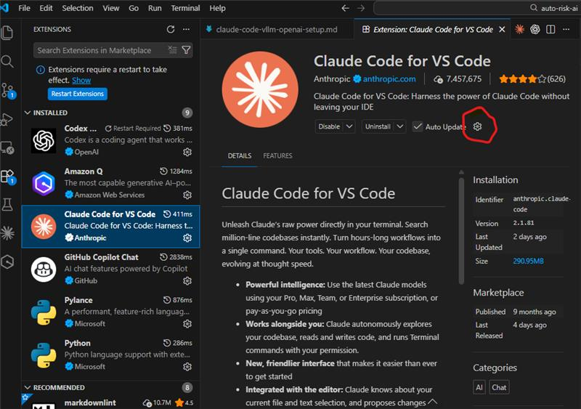

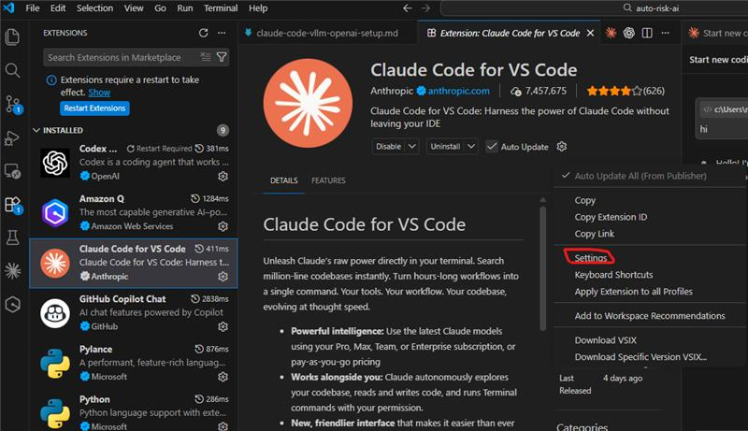

This opens up below page:
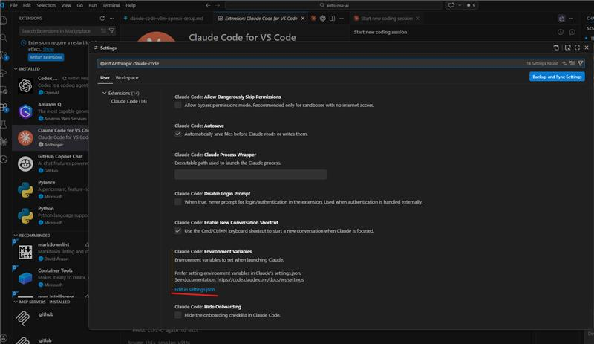

Click on Edit in settings.json as highlighted.
It should open the settings.json file and you can make changes in it.
Look for claudeCode.environmentVariables and add the two required environment variables.
{
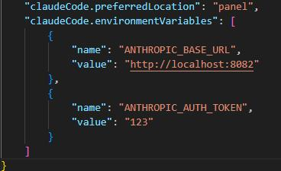

"name" : "ANTHROPIC_BASE_URL",
"value" : "http://localhost:8082"
},
{
"name" : "ANTHROPIC_AUTH_TOKEN",
"value" : "123"
}

Now your claude code extension in vscode will work with Generative Engine Free Tier model you selected.
- Restart VS Code
⚠️ This step is mandatory. Without restarting, Claude Code will not pick up the proxy configuration.

6. Prerequisites
Ensure the following are installed:
📍 Run in: VS Code Terminal / PowerShell / CMD
📍 Path: C:\Users\VRASAGNY\claude_code
6.1 Node.js
node -v
6.2 Python
python --version
6.3 Git
git --version

7. Install uv (Python Package Manager)
📍 Run in: VS Code Terminal (Recommended)
📍 Path: C:\Users\VRASAGNY\claude_code
📍 Run BEFORE cloning repo
Option 1 (Linux/Mac only)
curl -LsSf https://astral.sh/uv/install.sh | sh
Option 2 (Recommended for Windows)
pip install uv
Verify:
uv --version

8. Install Claude Code
📍 Run in: VS Code Terminal
📍 Path: ANY (global install)
npm install -g @anthropic-ai/claude-code
Verify:
claude --version

9. Setup Proxy Layer
9.1 Clone Repository
📍 Run in: VS Code Terminal
📍 Path: C:\Users\VRASAGNY\claude_code
git clone https://github.com/1rgs/claude-code-proxy.git
cd claude-code-proxy

9.2 Configure Environment File
📍 Run in: VS Code Terminal
📍 Path: C:\Users\VRASAGNY\claude_code\claude-code-proxy
cp .env.example .env
Edit .env:
OPENAI_API_KEY=your-generative-engine-api-key
PREFERRED_PROVIDER=openai
BIG_MODEL=gpt-oss:120b
SMALL_MODEL=gpt-oss:small
Replace:
- your-generative-engine-api-key with your actual key

9.3 Modify Token Limit
Open server.py
Find:
max_tokens = min(max_tokens, 16384)
Replace with:
max_tokens = min(max_tokens, 4000)

Important Step Before Running
👉 Restart VS Code again before proceeding
This ensures:
- Environment variables are applied
- Claude extension is properly initialized

9.4 Run Proxy Server
📍 Run in: VS Code Terminal
📍 Path: (anthropic-proxy) PS C:\Users\VRASAGNY\claude_code\claude-code-proxy> (IMPORTANT)
uv run uvicorn server:app --host 0.0.0.0 --port 8082 --reload
Expected:
Uvicorn running on http://0.0.0.0:8082
Keep this terminal running
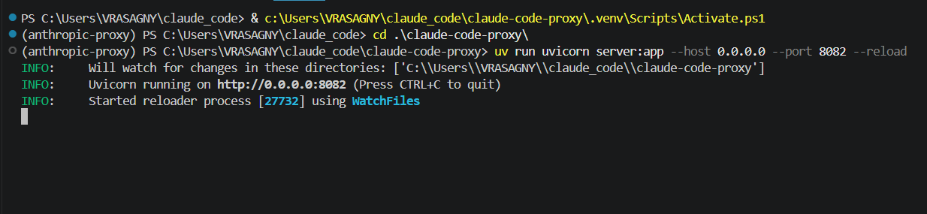

10. Connect Claude Code to Proxy (CLI Users)
Open a new terminal
📍 Open NEW terminal
📍 Run in: VS Code Terminal / PowerShell
If PowerShell
$env:ANTHROPIC_BASE_URL="http://localhost:8082"
$env:ANTHROPIC_AUTH_TOKEN="123"
If CMD
set ANTHROPIC_BASE_URL=http://localhost:8082
set ANTHROPIC_AUTH_TOKEN=123

11. Start Claude
Claude
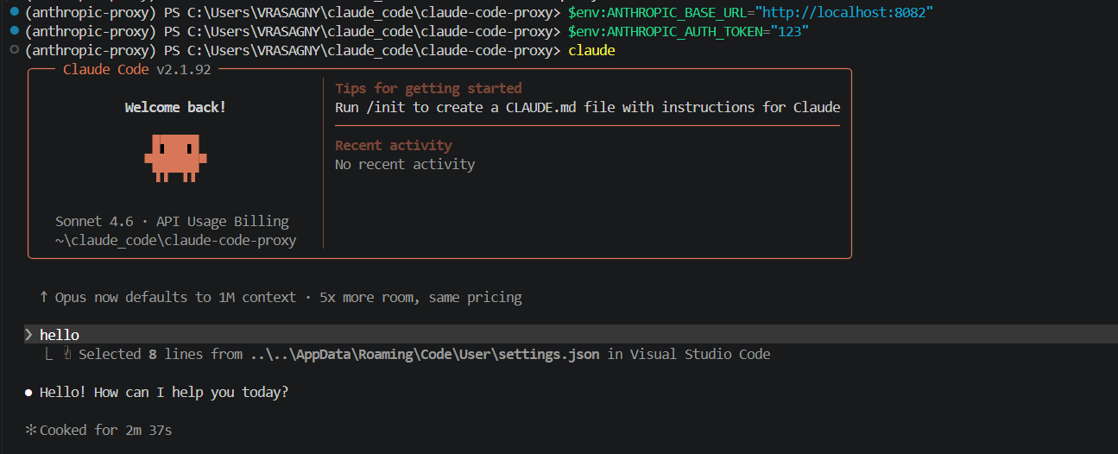

11. Verification
Step 1: Run a prompt
Hello
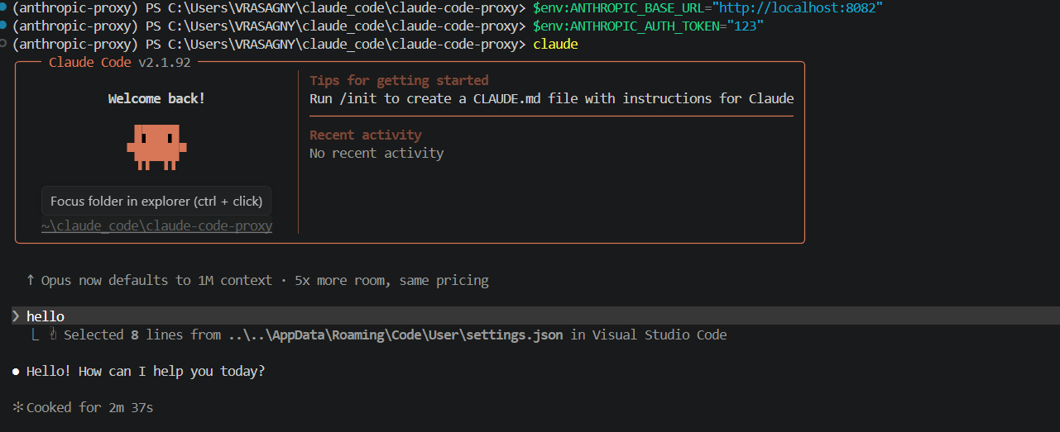

Step 2: Check proxy logs
Expected:
POST /v1/messages ✓ 200 OK
claude-sonnet-4-6 → gpt-oss:120b
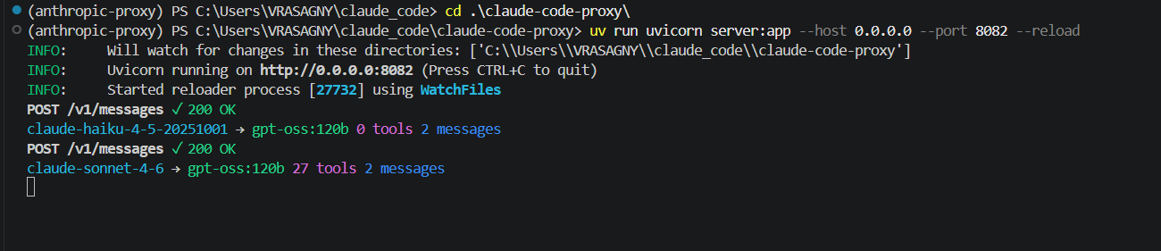

Step 3: Interpretation
- Claude request → claude-sonnet
- Proxy mapping → gpt-oss:120b
- Backend → Generative Engine

12. Model Selection Behavior
Using /model in Claude:
- Displays Claude models (Sonnet, Haiku, Opus)
- These are logical labels only
Actual Mapping
Claude Selection | Backend Model
Sonnet | BIG_MODEL
Haiku | SMALL_MODEL
Example:
claude-sonnet → gpt-oss:120b

13. Troubleshooting
Issue: Not logged in
Cause: Environment variables not set
Fix:
$env:ANTHROPIC_BASE_URL="http://localhost:8082"

Issue: ECONNREFUSED / Unable to connect
Cause: Proxy not running
Fix: Start proxy server

Issue: 404 Errors
Cause: Wrong endpoint or proxy not running

Issue: No response
Cause:
- Invalid API key
- Backend unreachable

Issue: Module import error
Cause: Running command outside correct directory
Fix:
cd claude-code-proxy

Issue: .env permission problem (Windows)
Fix:
Remove-Item .env
Copy-Item .env.example .env

14. Key Takeaways
- Claude Code remains unchanged
- Backend remains unchanged
- Proxy enables compatibility
Benefits
- Vendor independence
- Cost optimization
- Flexibility in model usage
- Ability to use free-tier models

15. Important Notes
- This setup is for learning and experimentation
- Free-tier models may have:
  - Rate limits
  - Lower performance
- Recommended LiteLLM version:
< 1.82.7

16. Summary
We successfully enabled Claude Code to work with Generative Engine by:
- Introducing a proxy layer
- Translating API formats
- Routing requests through the proxy
- Mapping Claude models to OpenAI-compatible models
This approach allows seamless integration of Claude Code with non-Anthropic backends.

